# CS 255 System Design Document Template

## UML Diagrams

### UML Use Case Diagram

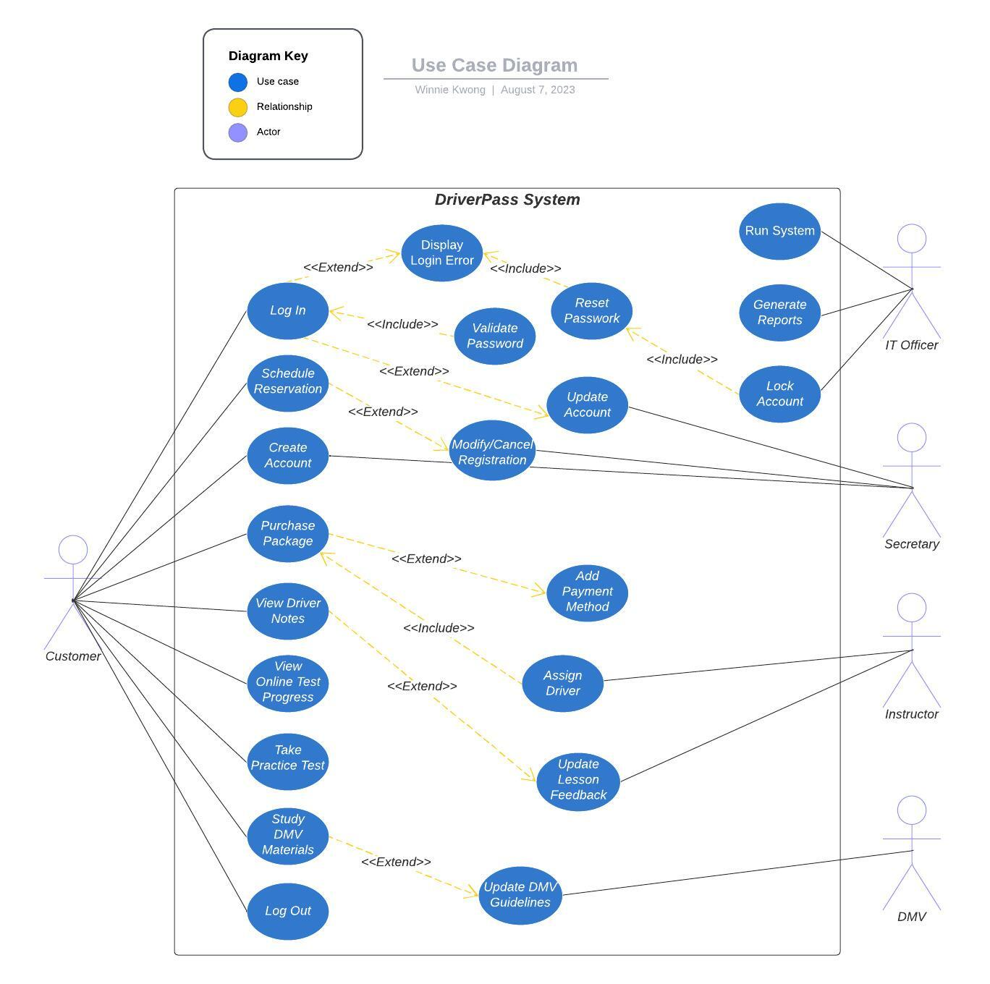

### UML Activity Diagrams

### UML Sequence Diagram

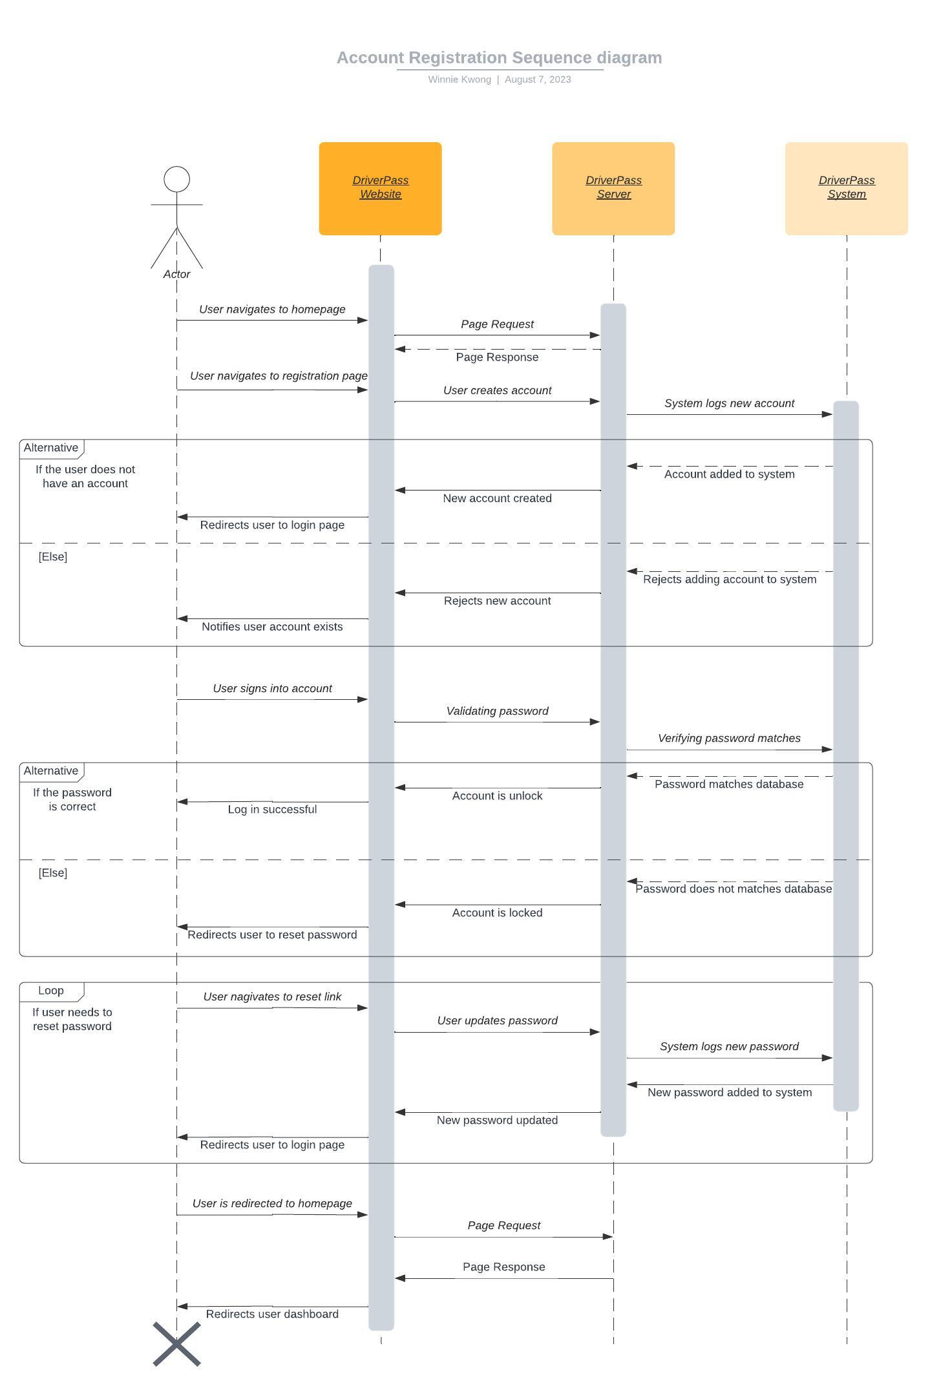

### UML Class Diagram

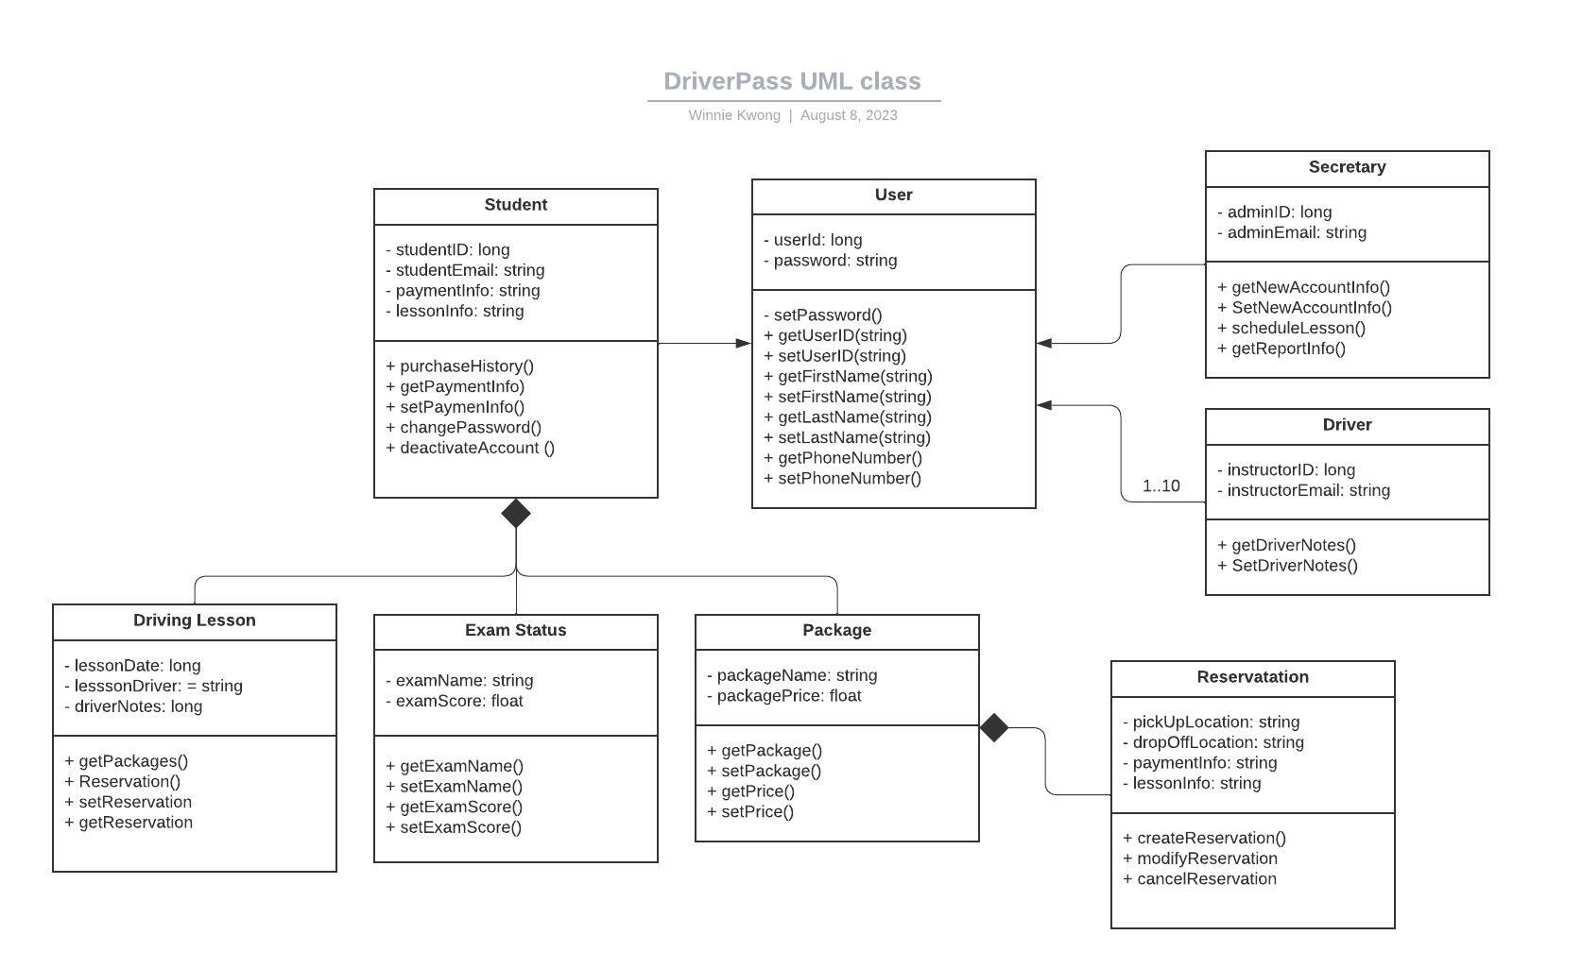

## Technical Requirements

* Hardware
  + Hardware must be able to manage minimum processor speed, memory, and disk space for performance and security standards.
  + Devices such as smart phone, tablets, laptops or desktops to access browsers
* Software
  + The software should include the latest security software to prevent malware and other malicious attacks.
  + The software must be able to perform within cross multi-platforms such as Mac, Linux, Window, Android, and iOS.
  + Cloud storage system to manage and track all data flow within DriverPass that includes customer information, payments, and package information.
  + The software must be able to offer test management tools, bug tracking, and visual bug reporting tools to maintain system updates.
* Tools
  + Tools to help track and manage daily tasks, such as Jira
  + Development stack to maintain frontend, backend and database layers.
* Infrastructure
  + High-speed Internet connection through wifi or hardwire.
  + Electricity to maintain all aspects of the infrastructure.
  + The application must also be user-friendly and visually appealing.